**Practical-06**

**Practical:6.1**

**Aim: Write a PHP program to find whether entered year is leap year or not.**

**Program:**

<html>

<head></head>

<body bgcolor="yellow" >

<?php

function year_check($my_year){

if ($my_year % 400 == 0)

print("<h1>It is a leap year</h1>");

else if ($my_year % 100 == 0)

print("<h1>It is not leap year</h1>");

else if ($my_year % 4 == 0)

print("<h1>It is a leap year<h1>");

else

print("<h1>It is not a leap year</h1>");

}

$my_year = 2022;

year_check($my_year);

?></body>

</html>

**Output:**

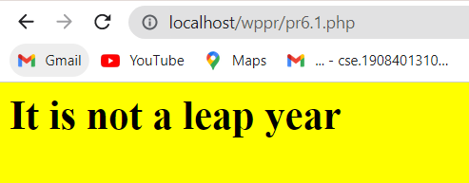

**Practical:6.2**

**Aim: Write a PHP program to display table of cube for 1 to 10.**

**Program:**

<html>

<head></head>

<body bgcolor="pink" >

<?php

$y=0;

for($i = 1; $i<=10; $i++){

$y= $i*$i*$i;

print"<h1>$y<br></h1>";

}

?>

</body>

</html>

Output:

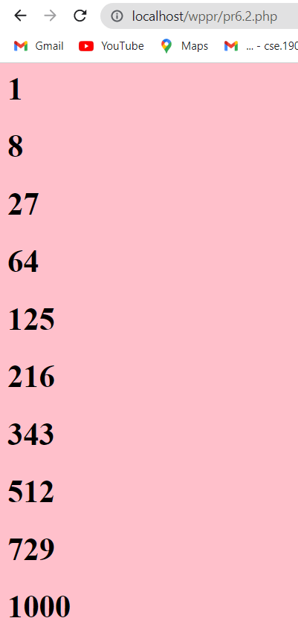

**Practical:6.3**

**Aim: Write a PHP program to read a text file and store it in array and display the content of array**.

**Program:**

<html>

<body bgcolor="blue">

<?php

$data=file("php.txt");

echo $data[0]."<br>";

echo $data[1]."<br>";

echo $data[2]."<br>";

?> </body>

</html>

**Output:**

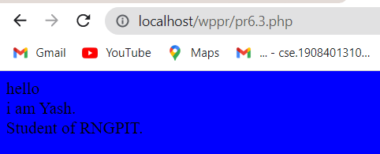

**Practical-6.4:** **Write PHP to store information of employee (employee id, job title, and years of experience) in an array. And output the data to a web page by arranging the employees in ascending order of experience.**

**Program:**

**pr-6_4.php**

<html>

<body>

<?php

include "pr-6values.php";

$emp_arr[] = array("eid" => "1", "jtitle" => "Android Developer", "eyear" => "2010");

$emp_arr[] = array("eid" => "2", "jtitle" => "Designer", "eyear" => "2005");

$emp_arr[] = array("eid" => "3", "jtitle" => "Web Developer", "eyear" => "2005");

foreach ($emp_arr as $userid => $user) {

$eid = $user['eid'];

$jtitle = $user['jtitle'];

$eyear = $user['eyear'];

$sql = "INSERT INTO pr_6_4(eid,jtitle,eyear) VALUES('" . $eid . "','" . $jtitle . "','" . $eyear . "')";

mysqli_query($con, $sql);

}

$sql = mysqli_query($con, "SELECT * FROM pr_6_4");

while ($row = mysqli_fetch_assoc($sql)) {

$eid = $row['eid'];

$jtitle = $row['jtitle'];

$eyear = $row['eyear'];

echo "Employee ID: " . $eid . ",Job Title : " . $jtitle . ", Years of Experience : " . $eyear . "<br>";

}

?>

</body>

</html>

**pr-6values.php**

<?php

$con = mysqli_connect("localhost","root","","employee");

// Check connection

if (mysqli_connect_errno()) {

echo "Failed to connect to MySQL: " . mysqli_connect_error();

exit();

}

?>

**OUTPUT:**

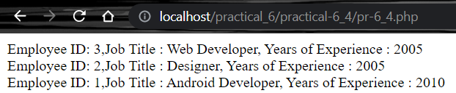

**Practical-6.5:** **Make a simple login form using cookie and session.**

**Program:**

**Pr6.5.1.php**

<html>

<body>

<?php

?>

<body>

<center>

<form action="pr6.5.2.php" method="post" style="margin-top: 50px; text-align:center; width: 400px;">

<p>

Username: <input name="username" type="text"

value="<?php if (isset($_COOKIE["username"]))

{ echo $_COOKIE["username"]; } ?>" class="input-field">

</p>

<p>

Password: <input name="password" type="password"

value="<?php if (isset($_COOKIE["password"]))

{ echo $_COOKIE["password"];} ?>" class="input-field">

</p>

<p><input type="checkbox" name="remember"> Remember </p>

<p><input type="submit" value="Login"></p>

</form>

</center>

</body>

</body>

</html>

**Pr6.5.2.php**

<?php

if (!empty($_POST["remember"])) {

setcookie("username", $_POST["username"], time() + 3600);

setcookie("password", $_POST["password"], time() + 3600);

echo "Cookies Set Successfuly";

} else {

setcookie("username", "");

setcookie("password", "");

echo "Cookies Not Set";

}

?>

<p><a href="pr-6_5.php"> Go to Login Page </a></p>

**Output:**

